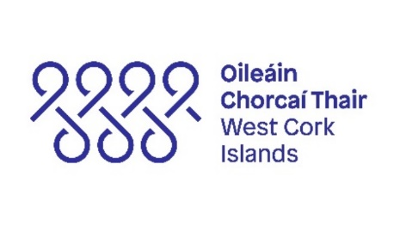

Creative Places West Cork Islands CPWCI) – Islander Residencies
Cape Clear / Oileán Chléire, Sherkin island / Inis Arcáin, Heir Island / Inis Uí Drisceoil, Long Island / An tOileán Fada, Whiddy island / Oileán Faoide, Bere island / An tOileán Mór, Dursey island / Oileán Bao

The Islander Residencies scheme is for artists, creatives, community groups and individuals who are residents of Oileán Chléire, Sherkin Island, Heir Island, Long Island, Whiddy Island, Bere Island and Dursey Islands and is for islanders to invite a collaborator / mentor to their island. The maximum amount under this award is €1,000. Funding is limited and we enthusiastically welcome requests for less than this amount. Please email this application and supporting documentation to peter.prendergast@corkcoco.ie with Islander Residencies in the subject line.

*(required)

Applicant Name*

Title of Project*

Email Address*

Contact Number*

Postal address with Eircode
(must be island based) *

Proposed start date if known*

Amount Requested*

Collaborator / mentor proposed *
Proposed duration, please describe. *

Will the proposed project/event provide opportunities for active participation by islanders, or will this be a solo project? Please describe. *

Will any other artists be involved in the project/event/activity? *

Project Details*
Give full details of the proposal/project/event or activity for which you are requesting funding including the collaborator / mentor you would like to work with.

Additional Details *(required)

Upload examples of similar and relevant work in this area you have done previously, images should include captions or short descriptions. * | ☐
Upload a short statement/or CV with background information on you or your group * | ☐
Link to examples of your previous work(s), if applicable. For videos/films/audio, please provide URL links (with a description) to your own website, Vimeo page, YouTube page, etc | ☐
Please upload any supporting documents relating to your proposed project including the collaborator / mentor. | ☐

Costs Related to Project*
Please outline the costs associated with the project and if the project is in receipt of any other income. Please upload a separate income and expenditure sheet if required. We enthusiastically welcome proposals that come in below that budget.

Please note: Additional information may be requested by the panel.

Date:

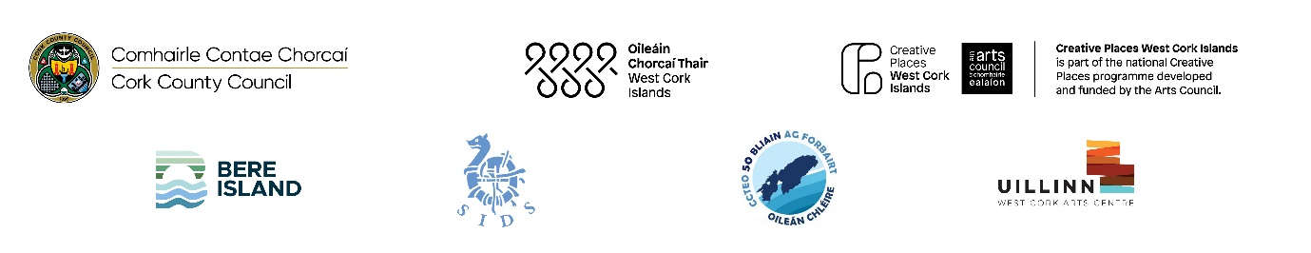

Creative Places West Cork Islands call for applications:

Islander Artist/Maker

GUIDELINES

Creative Places West Cork Islands is here…

Creative Places West Cork Islands (CPWCI) is an ambitious three-year culture-based community development programme for and about the West Cork islands. Creative Places aims to connect with people, artists, and places, to allow ideas to develop into creative actions that are inspired by and enrich our island communities. Creative Places is about harnessing the power of creativity, Culture & the Arts to support and sustain the Island communities of West Cork.

Context
CPWCI is a project focused on collaborative approaches to cultural production. It is rooted in socially engaged arts practice and community-development principles. Its focal points are the seven inhabited islands of West Cork and the coastal communities with connections to those islands.
CPWCI and our Project Partners invite artists, creatives, community groups and individuals who are residents of Oileán Chléire, Sherkin Island, Heir Island, Long Island, Whiddy Island, Bere Island and Dursey Island to participate in the Islander Artist/Maker Programme.
CPWCI is an Islands initiative with support from the Arts Council and Cork County Council.

Brief
The collaborator / mentor programme designed specifically for artists / makers and creatives living on the West Cork islands. The funding is to support creative projects by individuals, groups, artists, or makers that broadly fall within the following framework:
- Projects that strengthen existing local contemporary and traditional art practice, which could include craft, the making of artefacts and objects, the development of practical skills, visual sensitivity, and a working knowledge of tools, materials, and systems.
- Time and resources for an artist / maker to develop a body of work.
- Projects that are led by community participation and ideas.
- Make visible & strengthen the interconnectedness of the islands.
- Promotes the use of the Irish language in a cultural context.
- Projects that are socially engaged and positively impact islanders’ ongoing cultural participation and the preservation and promotion of unique island cultures.
- Give expression to what it is to be an islander through any artistic medium.
The available funding is up to a maximum of €1,000. We enthusiastically welcome proposals that come in below that budget.

What the project is not for:
- Capital expenditure.
- Expenditure that does not align with projects framework and priorities.
- People that have received a bursary award previously.

Application Procedure
Please fill out the application as best you can, the Project Coordinator will be in touch to work with you to finalise the details. This award is at the discretion of the Project Partnership.

Selection Process
All applications will be evaluated based on the information supplied. Only applications that respond adequately to the outlined criteria above will be considered. The Project Coordinator & Project Partners may seek additional information from the applicant solely for the purpose of clarifying the details provided.

Conditions of the award.
Please be aware that reporting to the project coordinator is an essential condition of any Creative Places West Cork Islands award and full transparency is required at all times from recipients of awards. A contract will be issued to successful recipients of awards and failure to adhere to contractual arrangement may lead to cancellation of the project with funds being reimbursed back to the Council.

Deadline
The deadline for this open call is August 4th 2025.
Additional Information

Seven Islands under the programme:
Oileán Chléire, Sherkin Island, Heir Island, Long Island, Whiddy Island, Bere Island & Dursey Island

Project Partners
Cork County Council, Comharchumann Chléire, Sherkin Island Development Society, Bere Island Projects Group & Uillinn - West Cork Arts Centre.
“Arts” means any creative or interpretative expression (whether traditional or contemporary) in whatever form, and includes, visual arts, theatre, literature, music, dance opera, film, circus, and architecture, and includes any medium when used for those purposes. (Arts Act 2003)
“Maker" refers to anyone designing and making individual artefacts and objects, encouraging the development of intellectual, creative, and practical skills, visual sensitivity, craft and a working knowledge of tools, materials and systems.

